Sample single-point rubric
Grows  Things I can work on | Criteria | Glows  Things I did well
 | I focused and listened during the meditative exercise.
 | I illustrated the three strategies that I think will work best for me.
 | I reflected on how I felt before and after meditation.

Sample reflection
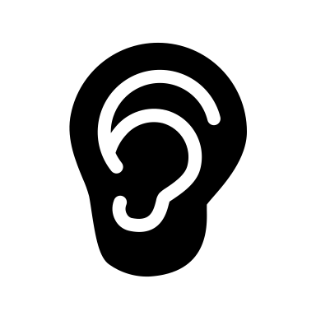  I focused and listened during the meditative exercise. | 

I illustrated the three strategies that I think will work best for me.
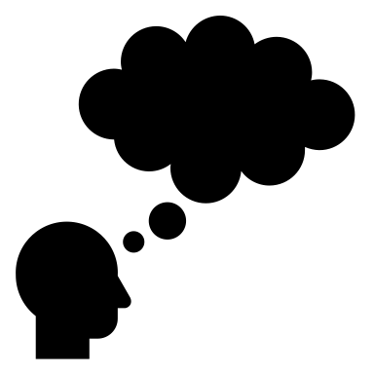
I reflected on how I felt before and after meditation.

